**Introduction to Twilio**

Twilio is a third-party SMS functionality provider. It is a cloud communications platform as a service (PaaS) company. Twilio allows software developers to programmatically make and receive phone calls and also send and receive text messages using its web service APIs.

**Please note that SMS delivery via a trial Twilio account is not guaranteed to be instant by Twilio. Also, note that SMS will not be sent to numbers which have DND(Do Not Disturb) turned ON.**

**Creating an account on Twilio**

Step 1: Open <https://www.twilio.com/> in browser.

Step 2: Click on [Get a Free API Key](https://www.twilio.com/try-twilio) button to sign up.

Step 3: Fill all the necessary details in SIGN UP form. Below is the screenshot of filled sign up form.

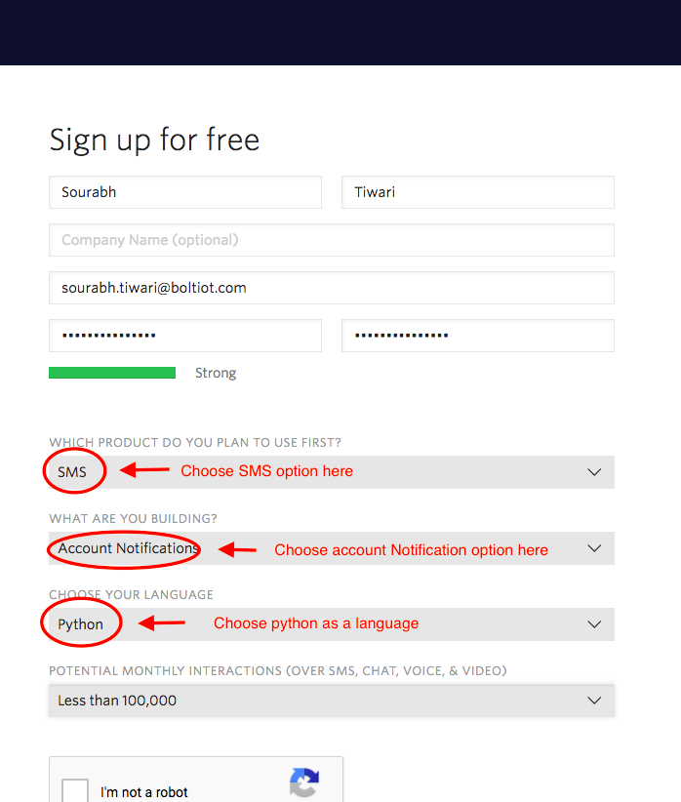

Step 4: To verify they will ask for your phone number. Choose India as an option in the dropdown and then enter your phone number.

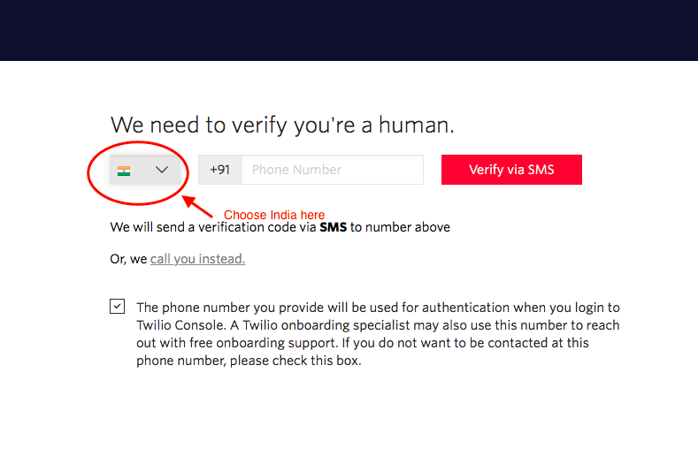

Step 5: Click on "Products" as shown on the screen below,

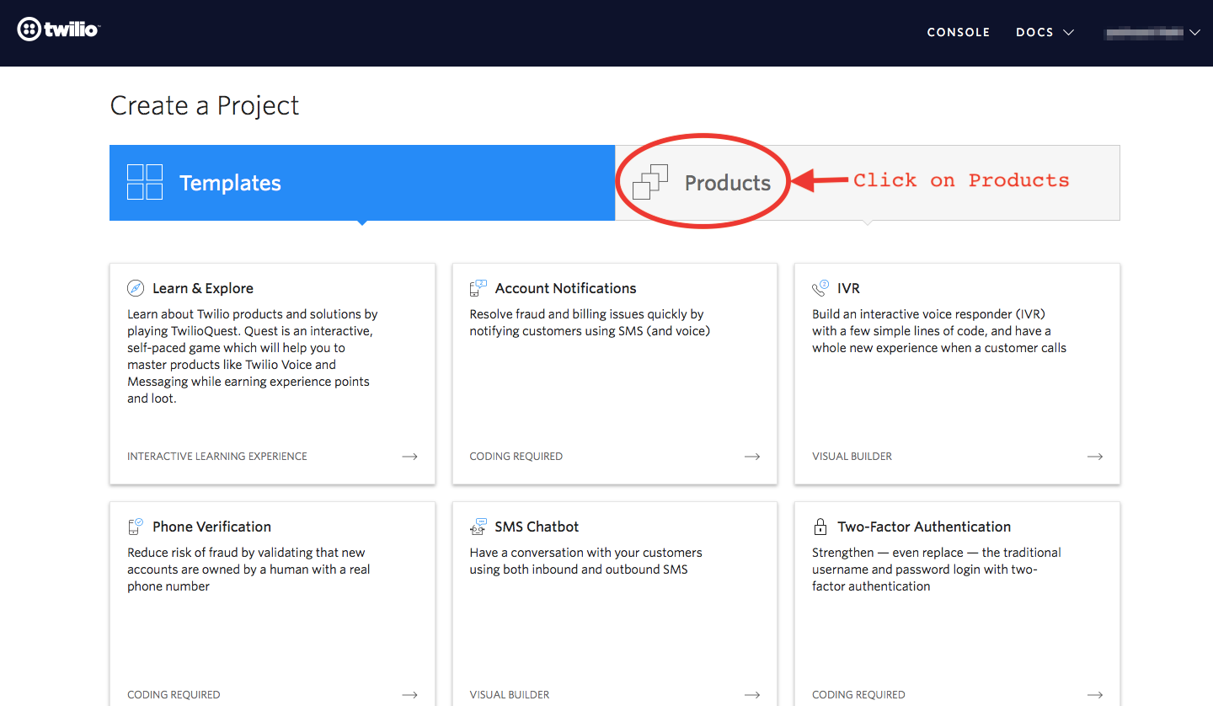

Step 6: Now enable the SMS services by clicking on two checkboxes for Programmable SMS and Phone Numbers as shown below.

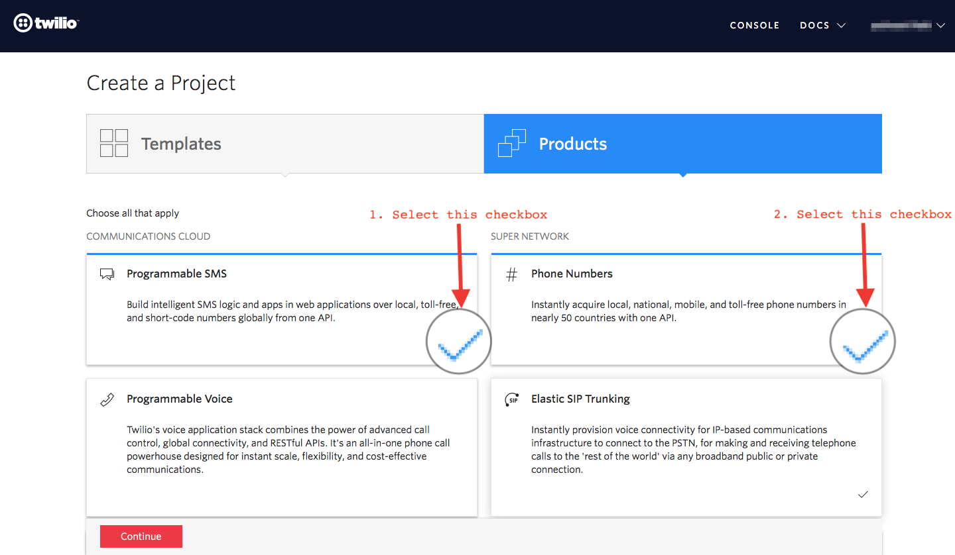

Once you have done this, scroll to the bottom of the screen and click on "Continue".

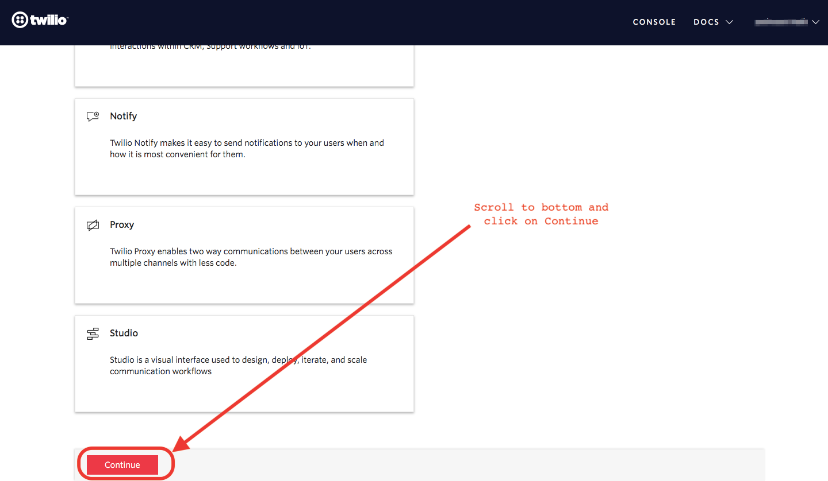

Step 7: Now, you will need to give a name for your project. I have given the name as My Project. Click on "Continue" once you have entered the project name.

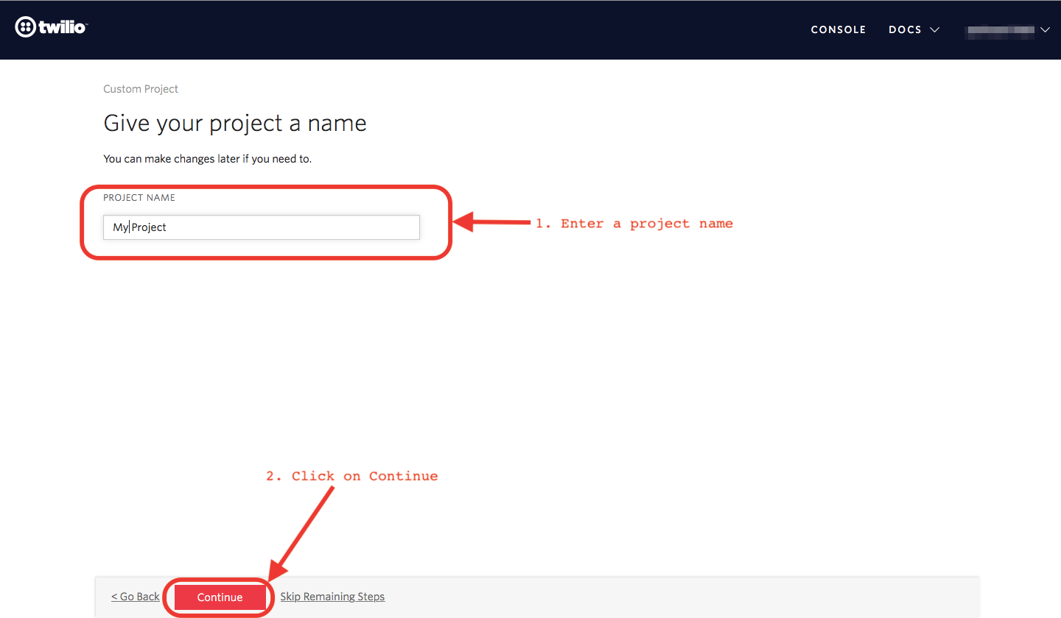

Step 8: Click on "Skip this step" when it asks you to Invite a Teammate.

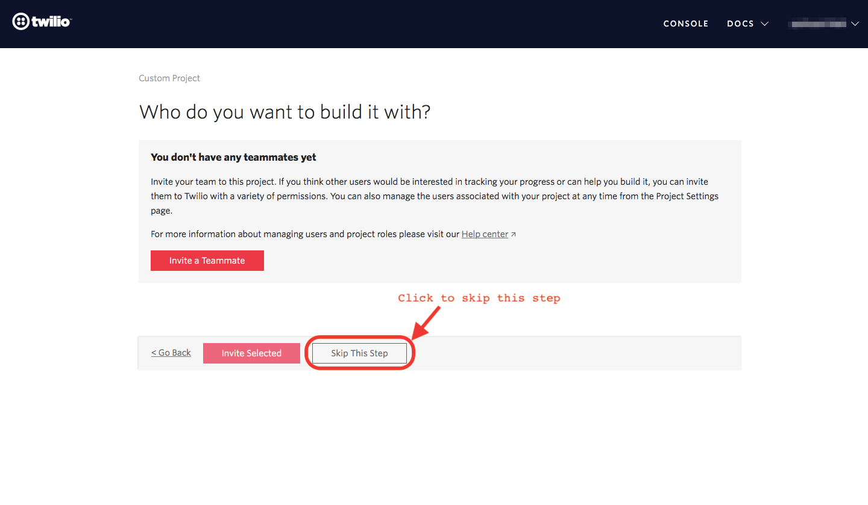

Step 9: Your project should be created at this point. Click on "Project Info" to view the account credentials which is required for your projects.

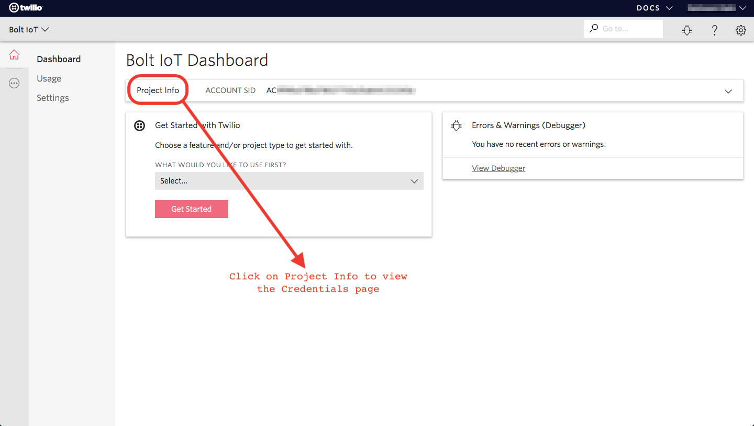

Step 10: You can view the Account SID and Auth token on this page. The Auth token is not visible by default, you can click on "view" button to make the Auth token visible as shown below. Copy both and save them somewhere securely.

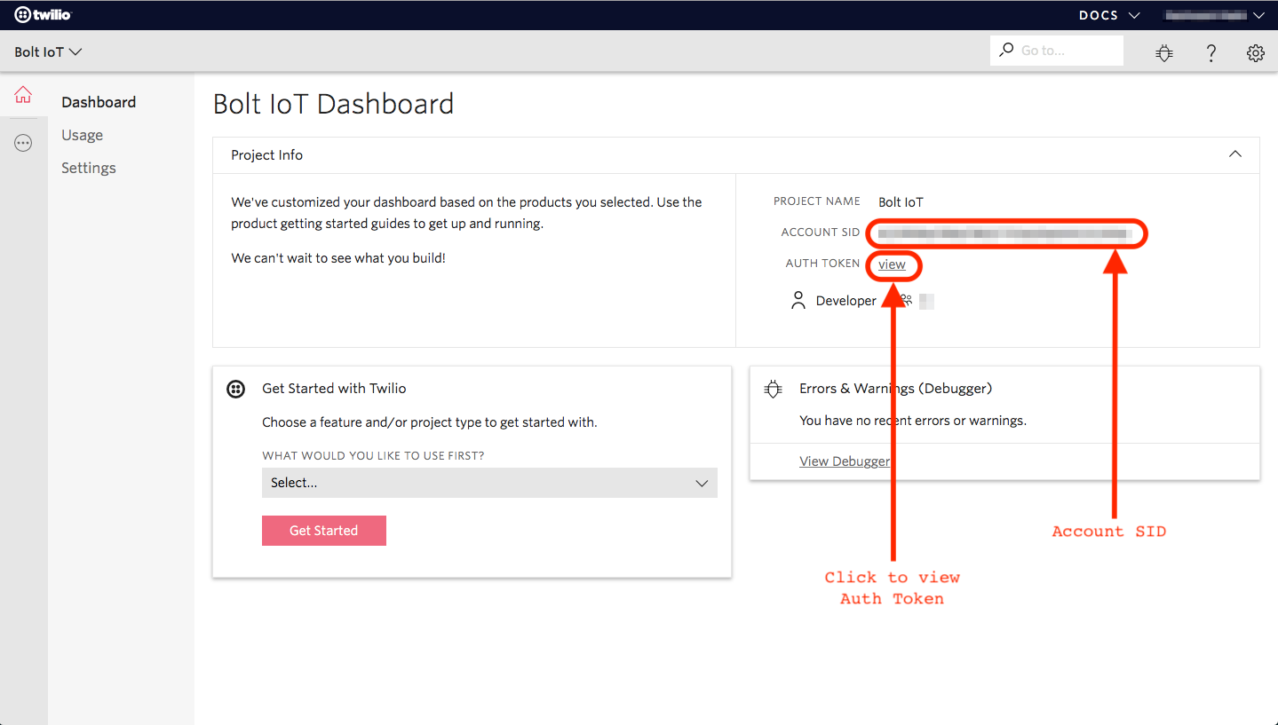

Step 11: From the drop-down menu, choose "Programmable SMS". Now click on Get Started button to generate phone number.

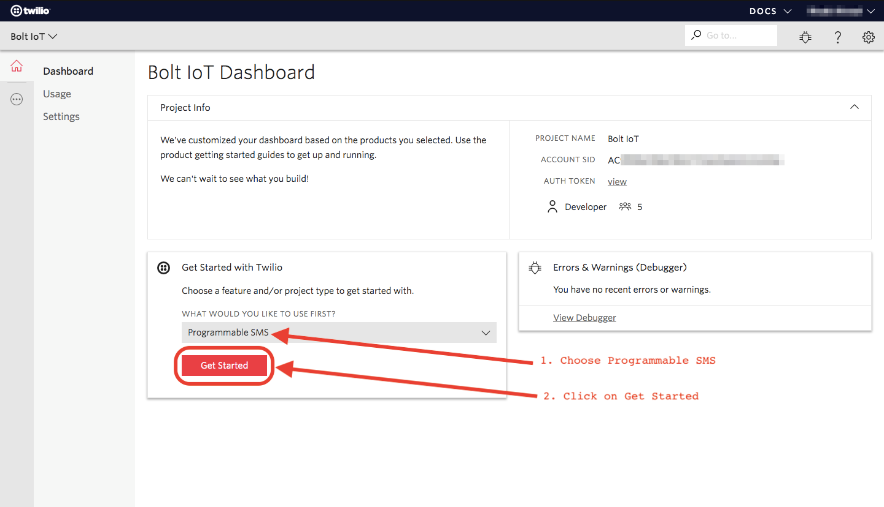

Step 12: Click on Get a number button.

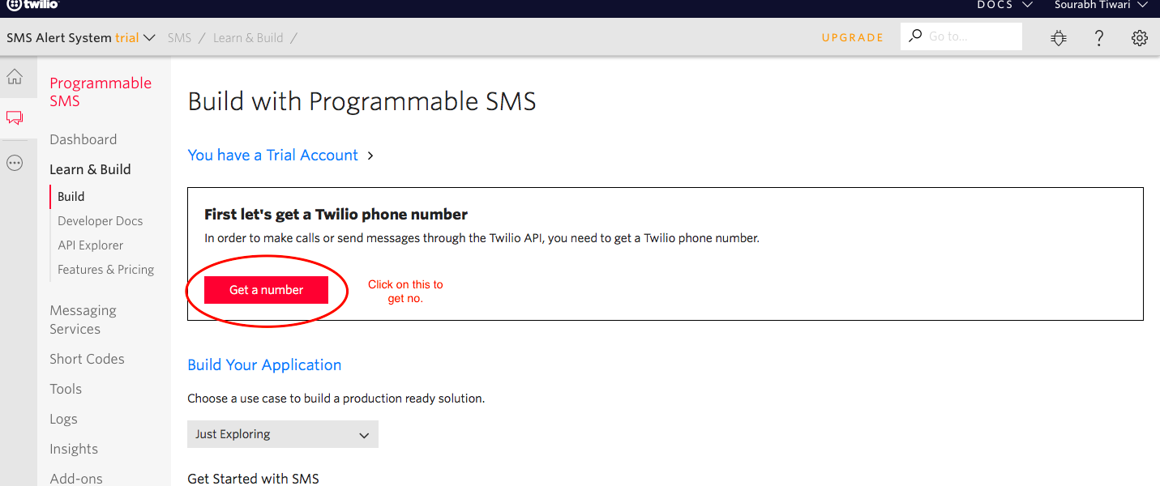

Step 13: Then a popup will appear. Click on Choose this number button.

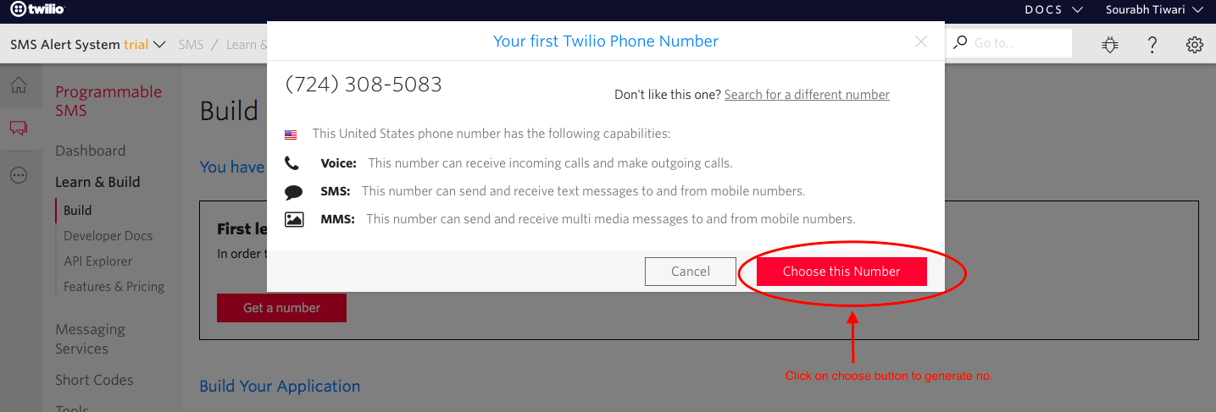

Step 14: Then a popup will appear which will have the final number. Copy this number and save to notepad for future references.

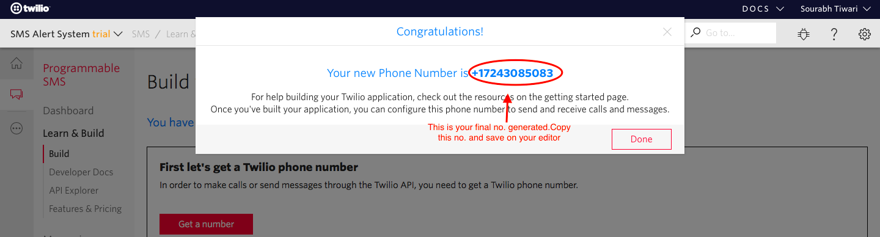

That's it. You have successfully created the account on Twilio. In the next lesson, we will use Bolt Python library to create our own SMS Alert system.